Name: maram sripathi

Reg no: 192311182

JAVA FOUNDATIONS :

PRACTICES – SECTION 5

PRACTICE 5-1 : DETERMINING COLOR IN THE VISIBLE SPECTRUM

PROGRAM :-

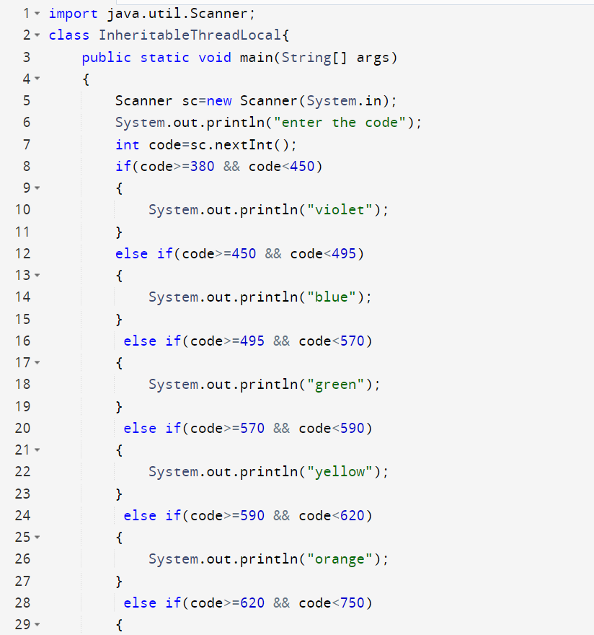

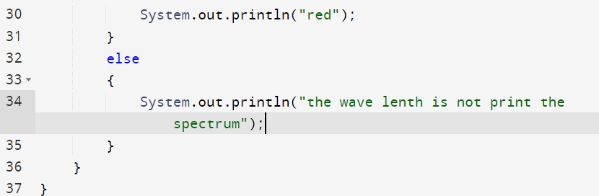

OUTPUT:-

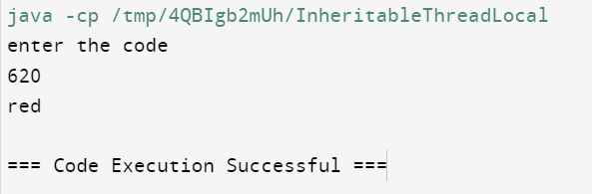

PROBLEM 5-2 : DETERMINING THE NEXT COLOR FOR A STOP LIGHT

PROGRAM:-

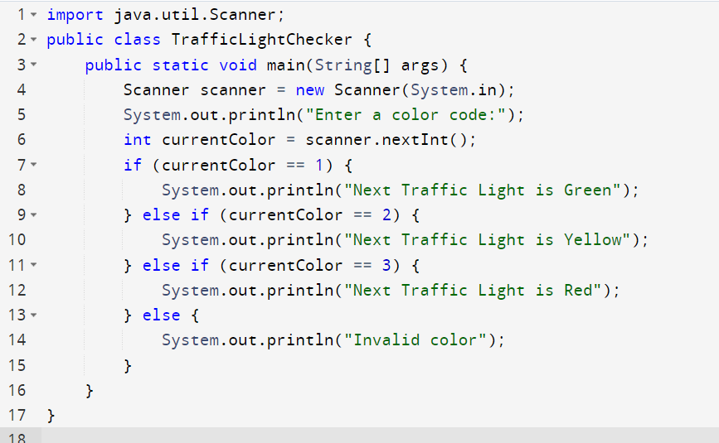

OUTPUT :-

